1.

129.23.1.1 Interface Default

129.22.151.22 Interface 1

129.22.150.78 Interface 14

129.22.150.106 Interface 8

2.

a. It contains 8 subnets.

b. Computers X Y Z and that other one… X MAC Address: af-12-53-d3-4d-5d, Y MAC Address: 00-01-02-af-2d, Z MAC Address: 10-d3-b5-b7-4d-33, That Other Computer MAC Address: 33-44-55-66-33-22

c.

Frame is sent to B

Switch Table B

|  |  |
| --- | --- |
| Switch | Mac |
| b3 | 0:0:0:0:0:0:0:1 |
|  |  |

Since B doesn’t have 2 on it’s switching table the frame is transmitted to all the other ports on the table

Switching Table for A

|  |  |
| --- | --- |
| Switch | Mac |
| a1 | 0:0:0:0:0:0:0:1 |
|  |  |

Switch Table B

|  |  |
| --- | --- |
| Switch | Mac |
| b3 | 0:0:0:0:0:0:0:1 |
|  |  |

Switch Table C

|  |  |
| --- | --- |
| Switch | Mac |
|  |  |
|  |  |

A doesn’t have 2 in its switching table, so it forwards it to all ports, meanwhile, Y gets the packet from B

Switch table A

|  |  |
| --- | --- |
| Switch | Mac |
| a1 | 0:0:0:0:0:0:0:1 |
|  |  |

Switch Table B

|  |  |
| --- | --- |
| Switch | Mac |
| b3 | 0:0:0:0:0:0:0:1 |
|  |  |

Switch Table C

|  |  |
| --- | --- |
| Switch | Mac |
|  |  |
|  |  |

C receives the frame and forwards it to Y and comp 3, but then nothing happens

|  |  |
| --- | --- |
| Switch | Mac |
| a1 | 0:0:0:0:0:0:0:1 |
|  |  |

Switch Table B

|  |  |
| --- | --- |
| Switch | Mac |
| b3 | 0:0:0:0:0:0:0:1 |
|  |  |

Switch Table C

|  |  |
| --- | --- |
| Switch | Mac |
| c1 | 0:0:0:0:0:0:0:1 |
|  |  |

d)

Frame from Y gets sent to B

Switch Table B

|  |  |
| --- | --- |
| Switch | Mac |
| b3 | 0:0:0:0:0:0:0:1 |
| b2 | 0:0:0:0:0:0:0:2 |

B has 1 on it’s switching table, it sends the frame down on b3

e)

Assume that we are back to all switching tables being empty.  When a frame needs sent from X →  Y, it gets broadcasted again by B, then by A, then C broadcasts it to 3rd Comp, Z, and B.  This loops, and any frames sent with a destination in none of the switching tables will bounce around infinitely between the three switches.

3.

Definitely not. Say X and Z are the two nodes. If Z starts transmitting a frame at t = 0 it’s going to finish transmitting at t = 576. Using this scale then, even if X starts transmitting at the last possible second, which would be t = 224 in this case (from the 225 bit time delay) then the message would arrive at t – 224 + the propogation delay of 225 for a total time of t = 449. This is less than the time it takes for A to transmit, so A is aborted. There is no malfunction as it was detected and aborted properly.

4. a.

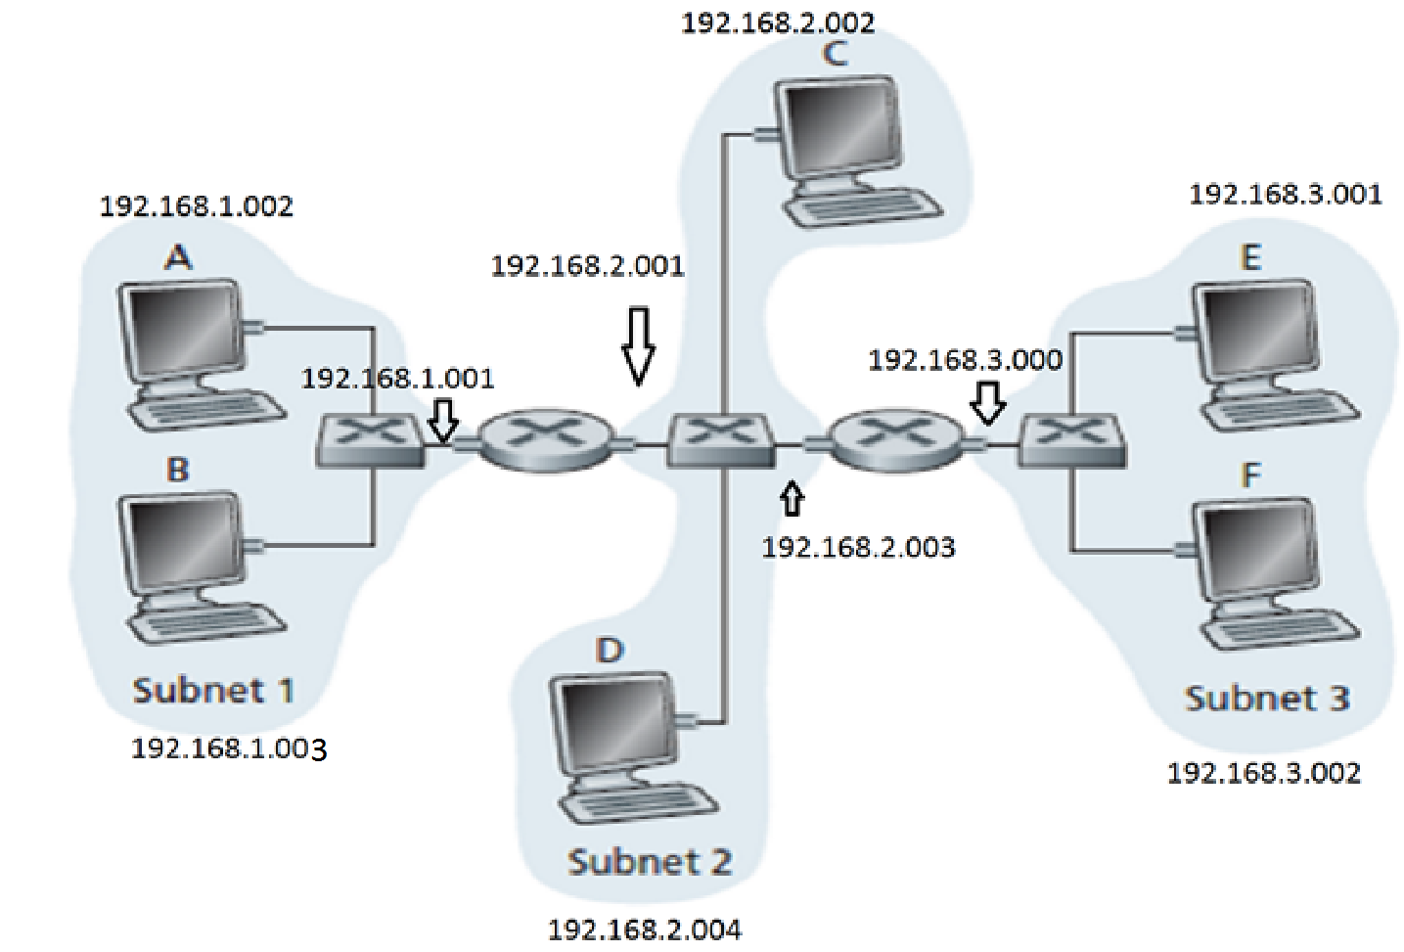

b.

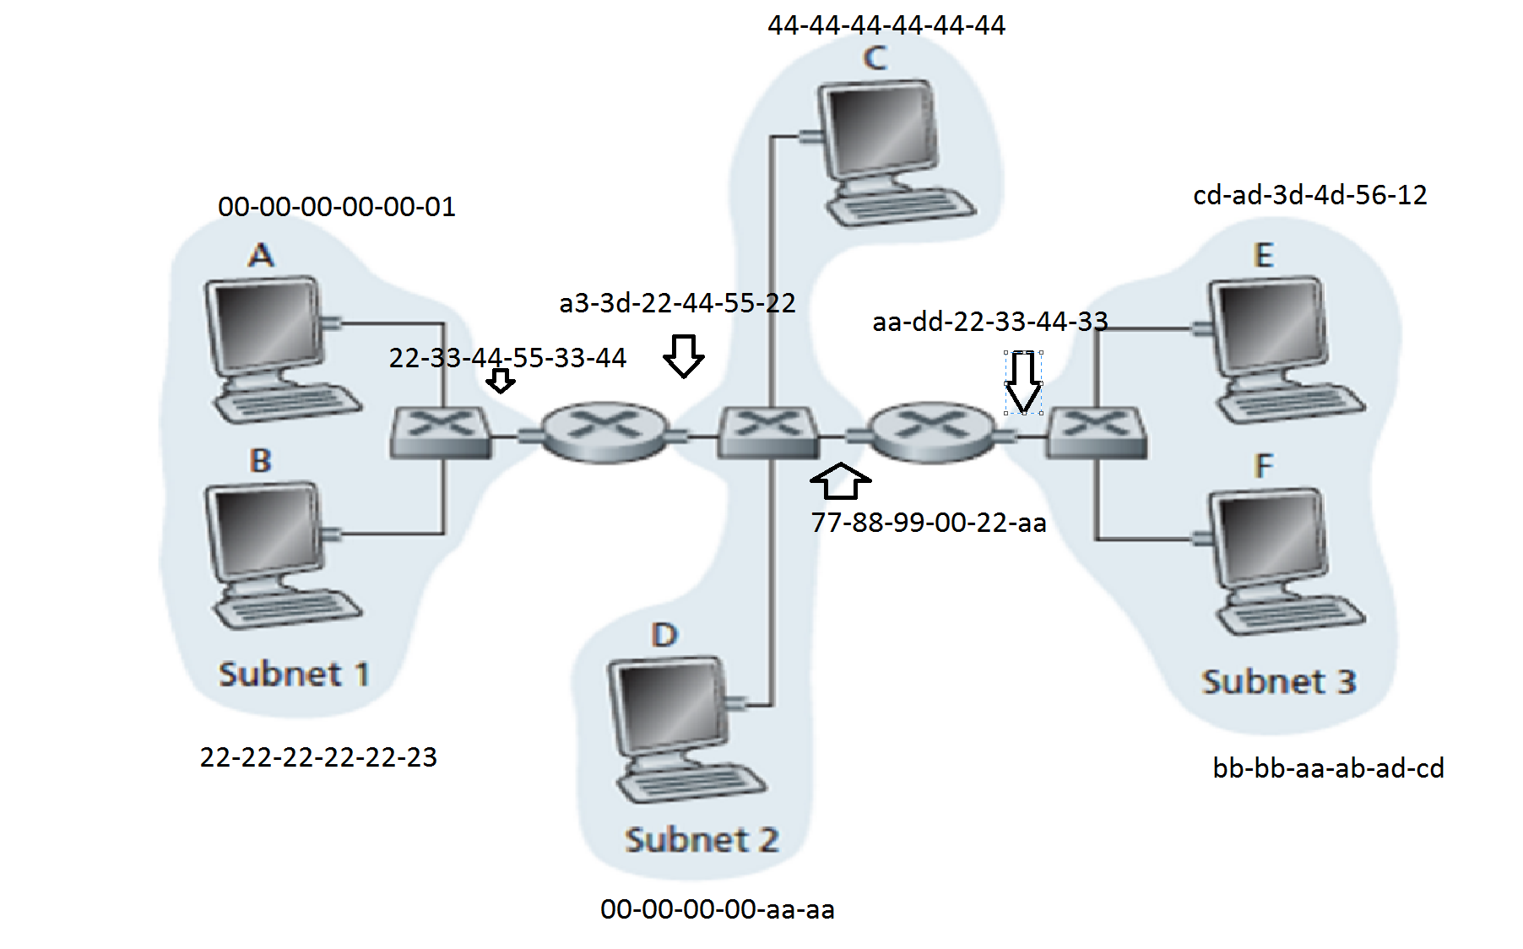

c.

* Step 1 is that the forwarding table in host E decides the datagram should be sent to interface 192.168.3.000.
* Then the forwarding table in host E figures out that the LAN address for 192.163.000 with MAC Address aa-dd-22-33-44-33.
* E sends the packet and the router receives it. The forwarding table in the router sends the datagram to router 192.168.2.001 and MAC Address a3-3d-22-44-55-22.
* This router then sends the datagram to 192.168.1.001 with MAC Address 22-33-44-55-33-44.
* Now this new router determines from its forwarding table that the datagram should be sent to 192.168.1.003 which is host B.

d.

When the ARP tables are empty the process is the same except for the first step. Host E has to send out a broadcast with an ARP query packet asking for 192.168.3.000. When the router responds saying that it is 192.168.3.000 and that it’s destination MAC address is aa-dd-22-33-44-33. The rest then proceeds as above.

5.

R6

|  |  |  |  |
| --- | --- | --- | --- |
| In Label | Out Label | Dest | Out Interface |
|  | 7 | A | 0 |

R5

|  |  |  |  |
| --- | --- | --- | --- |
| In Label | Out Label | Dest | Out Interface |
|  | 5 | A | 0 |

R4

|  |  |  |  |
| --- | --- | --- | --- |
| In Label | Out Label | Dest | Out Interface |
| 7 | 10 | A | 0 |
|  | 12 | D | 0 |
| 5 | 8 | A | 1 |

6.

a.

H will have a private IP address, and AP will have a private and public IP address. The DHCP server will get its own private IP address. The router should have a public IP address and the DHCP server for the ISP has a public IP as well.

Private IPS

Subnet A

H: 192.168.1.001

AP: 192.168.1.000 (priv)

DHCP in AP: 192.168.1.002

AP: 100.100.2.000 (pub)

Public IPs

Subnet C

Router R: 100.100.1.000

DHCP S: 100.100.1.001

Router R: 100.101.3.123 (public internet facing)

b.

|  |  |
| --- | --- |
| From H to AP | 802.11 header info  address 2: 00-00-00-00-00-01   Address 1: 00-00-00-00-00-02   Address 3: 00-00-00-00-00-02  ip header info:  source ip address: 192.168.123.3  destination ip address: x  TCP header info  source port: 86394  destination port: 54943 |
| From AP to switch: | ethernet header:  source MAC address: 00-00-00-00-00-03  Destination MAC address: 00-00-00-00-00-04  IP header:  IP addr: 192.123.123.101  Dest. IP addr: X  TCP header:  source port: 42354  destination port: 54943 |
| From R to the internet | ethernet header:  source MAC address: 00-00-00-00-00-05  destination MAC address: 00-00-00-00-00-06  TCP and ip ones don’t change. |

|  |  |
| --- | --- |
| From the internet to R | ethernet header:   source MAC address: MAC addr of the upstream router   destination MAC address: 00-00-00-00-00-05  ip header  source ip addr: X  destination ip address: 192.123.123.101  TCP header:  Source port: 54943  Dest. Port: 42354 |
| From R to switch | ethernet header:  source MAC address: 00-00-00-00-00-04  Dest: MAC addr: 00-00-00-00-00-03  TCP and ip ones don’t change. |
| From AP to H | 802.11 header:  address 2: 00-00-00-00-00-02  address 1: 00-00-00-00-00-01  address 3: 00-00-00-00-00-02 (router)  ip header:  source ip address: x  destination ip address: 192.168.123.5  TCP header:    Source port: 54943     Dest. Port: 42354 |